Electrical Transmission & Distribution Partnership

Continuing Education Training

Presenter Guide – Q2 – Fatigue Management: Strategies for Workplace Safety & Productivity

Introduction:
This Continuing Education Refresher course is a presenter lead (supervisor, safety professional) process. The presenter may choose to augment the material with videos, handouts, or other media to enhance the learning experience. The presenter may want to incorporate visual aids to enhance the presentation.

Using this material in combination with practical experience, good presentation skills and knowledge of adult learning techniques, the presenter has a greater opportunity to deliver the information.

Edgar Dale stated that 2 weeks after a learning event, adult learners remember:

- 10% of what they read
- 20% of what they hear
- 30% of what they see
- 50% of what they see and hear
- 70% of what they say
- 90% of what they say while performing a task

Microsoft® PowerPoint® combined with good instructional skills and instructor/student dialogue work strongly in the fifty to seventy percent range. PowerPoint® presents the information to the attendee and the instructor summarizes the content of the slides. It is critical to engage and involve the attendee in the process. Ask open-ended questions that will elicit conversation and discussion but be cautious to maintain control of the discussion.

Conversation and scenarios are good but can cause the discussion to run long. If it seems like the group is losing focus during the course, the presenter can direct the group back on track by using comments like "Good discussion, but let's get back to the subject at hand".

Another tool is the "Parking Lot" which is simply a newsprint chart or dry erase board or note pad where the presenter records questions/discussion points not answered or addressed during the meeting and that may require more research. It is vital to capture any ongoing discussions or questions on the "Parking Lot" and follow up when the information is known.

Deliver this refresher during the second quarter of 2025. Delivery time is approximately 45 minutes to 1 hour, in one setting or divided- up into three, 15-to-twenty-minute settings. The presenter may deliver the topic in a formalized meeting room setting using the PowerPoint slide deck or by using the three, key point sheets (located at the end of each session) as in a tailgate safety talk. It is critical that the facilitator makes him or herself familiar with the material prior to delivery.

This page left intentionally blank.

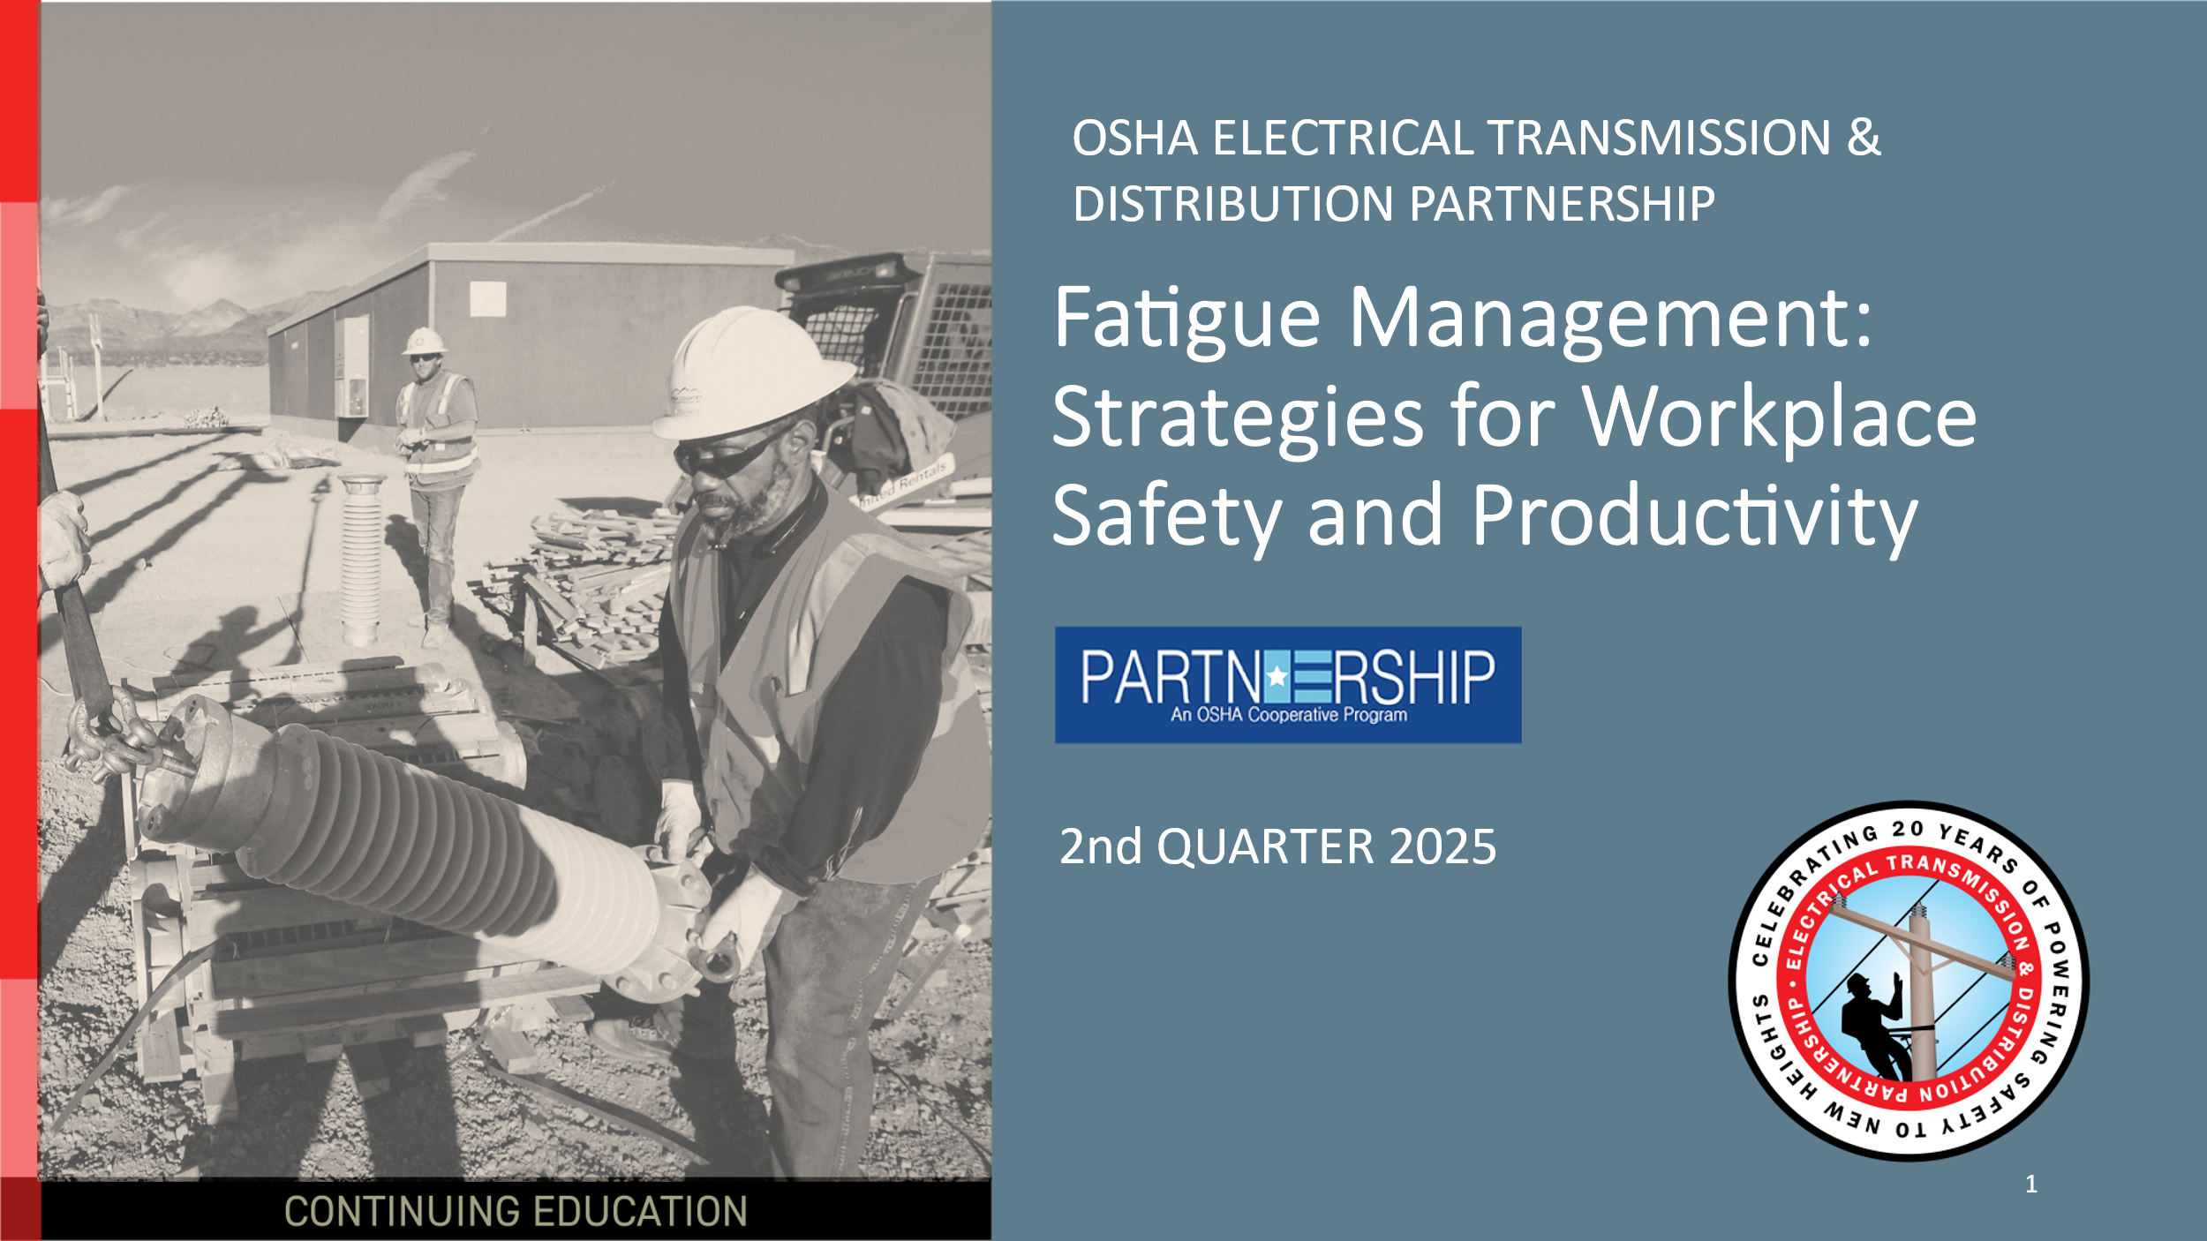

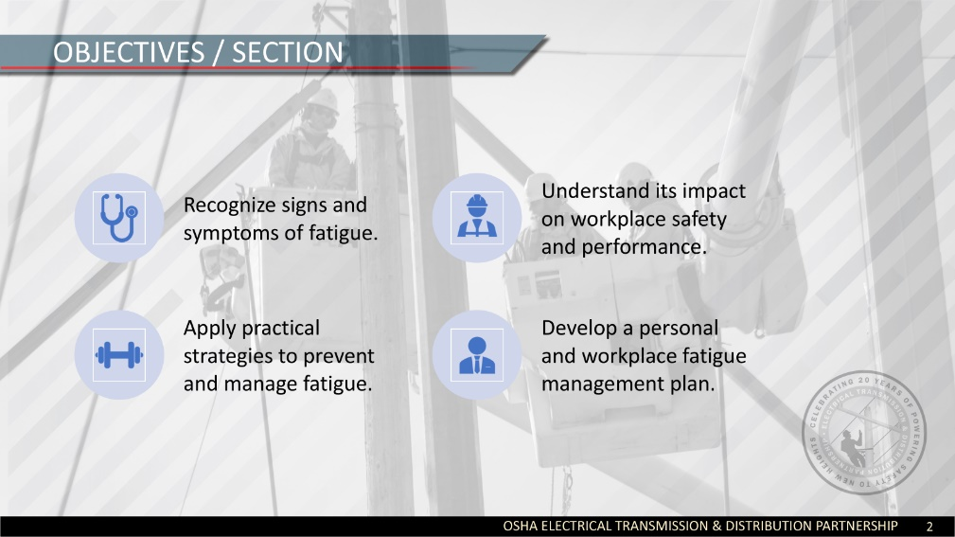
🗣 Say:
"Before we dive into today’s content, let’s take a moment to go over what you can expect from this session."
🔹 Engage Participants:
- Ask: “Has fatigue ever affected your work performance or safety?”
- Invite 1-2 participants to share quick responses.
- Reinforce that fatigue is a shared workplace challenge and this session will provide practical strategies to manage it.
Breakdown of Learning Objectives
🔹 Objective 1: Recognizing Signs and Symptoms of Fatigue
- 🗣 Say: "First, we’ll focus on how to identify fatigue in yourself and others. It’s not just about feeling sleepy fatigue affects concentration, reaction time, and even mood."
- 🏷 Example: "Think about the last time you struggled to focus on work—what were the signs?"
🔹 Objective 2: Understanding the Impact of Fatigue on Safety and Performance
- 🗣 Say: "Fatigue doesn’t just make us tired—it increases safety risks and leads to costly mistakes. We’ll look at real-world examples of workplace incidents linked to fatigue."
- 🏷 Example: "Have you ever seen an accident or near-miss where fatigue played a role?"
🔹 Objective 3: Applying Strategies for Fatigue Prevention and Management
- 🗣 Say: "We’re not just here to talk about the problem—we’re here to find solutions. We’ll go over personal and workplace strategies to manage fatigue effectively."
- 🏷 Example: "How many of you take short breaks throughout your shift? We’ll discuss how even small adjustments can make a big difference."
🔹 Objective 4: Developing a Fatigue Management Plan
- 🗣 Say: "Finally, you’ll walk away with a practical plan—both for yourself and your team. This will help ensure that fatigue is addressed as a safety and productivity issue, not just an individual concern."

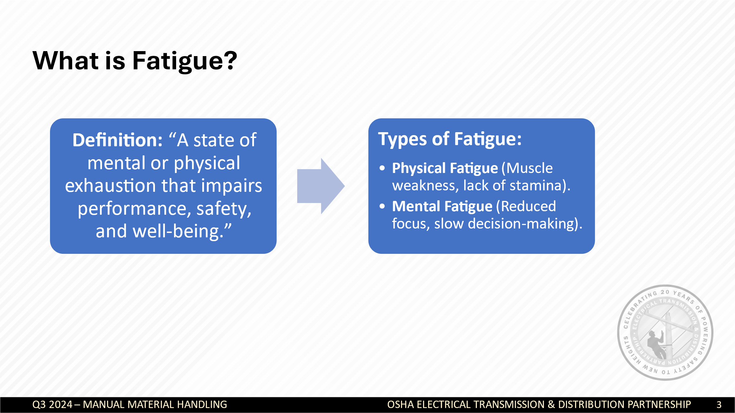
1. Introduce the Concept of Fatigue
- Say: “Fatigue is more than just feeling tired—it’s a state of exhaustion that affects both the body and mind. It reduces our ability to perform tasks safely and effectively, which is why we’re discussing it today.”
- Ask the audience: “When you hear the word ‘fatigue,’ what comes to mind?” (Take 1-2 quick responses.)
2. Explain the Definition of Fatigue
- Read the definition on the slide.
- Emphasize: “Fatigue is not just about lack of sleep—it can be caused by overexertion, long work hours, stress, and even dehydration.”
- Provide an example:
  - “Imagine working a 12-hour shift outdoors in high heat. By the end, your muscles feel weak, your reaction time is slower, and even simple tasks require extra effort. That’s fatigue.”
  - “Now, think about a long day of problem-solving or data entry. Even if you’re not physically tired, your ability to focus and make decisions declines. That’s mental fatigue.”
3. Compare Physical and Mental Fatigue
- Physical Fatigue:
  - “This type of fatigue happens when your body is overworked. You might feel sore, weak, or unable to perform physical tasks effectively.”
  - Example: “A lineman working on power lines all day, climbing poles, and lifting heavy equipment will experience physical fatigue.”
  - Question to the group: “What are some jobs where physical fatigue is a major concern?” (Take a few responses.)
- Mental Fatigue:
  - “Mental fatigue happens when your brain is overworked. You may struggle to concentrate, forget things, or make mistakes.”
  - Example: “A dispatcher managing emergency calls for hours without breaks may feel mentally drained, leading to slower decision-making.”
  - Question to the group: “Has anyone ever felt mentally exhausted even after sitting at a desk all day?” (Encourage 1-2 quick responses.)

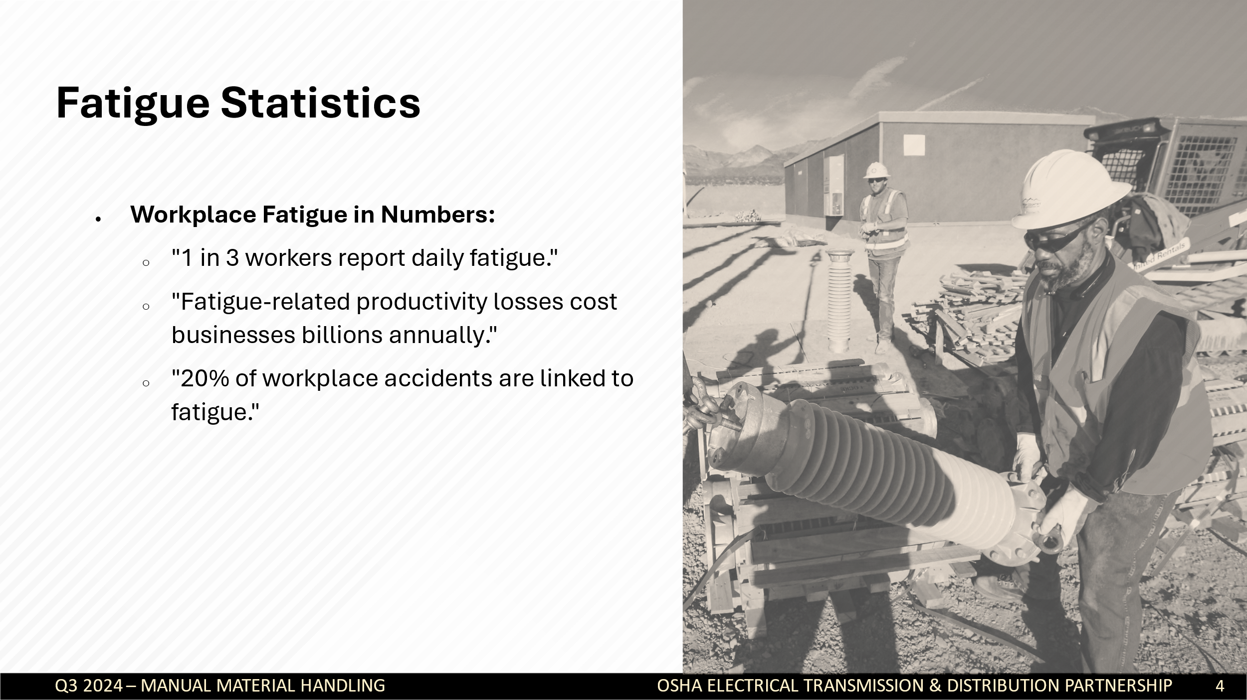
💬 Say:
"Fatigue is more than just feeling tired—it’s a serious workplace hazard. Let's look at some statistics that highlight just how common and costly fatigue can be."
❓ Ask the audience:
- “How many of you have felt fatigued while on the job?”
- “Have you ever seen someone make a mistake at work due to fatigue?”
➡ Encourage responses and make it interactive.
Breakdown of Statistics
📊 Statistic 1: "1 in 3 workers report daily fatigue."
💬 Say:
"One in three workers struggles with fatigue every day. That means if you look around this room, chances are multiple people here experience fatigue regularly. It’s a common issue, but because it’s invisible, it’s often overlooked."
🔹 Discussion Prompt:
- “Why do you think so many workers experience fatigue daily?”
- Possible Answers: Long hours, demanding jobs, poor sleep, stress, lifestyle factors.
📊 Statistic 2: "Fatigue-related productivity losses cost businesses billions annually."
💬 Say:
"Fatigue isn’t just a safety risk—it’s a productivity issue too. Studies estimate that businesses lose billions of dollars annually due to fatigued employees working less efficiently, making mistakes, or needing more sick days."
🔹 Ask:
- “Have you ever noticed a time when fatigue made you work slower or less efficiently?”
📊 Statistic 3: "20% of workplace accidents are linked to fatigue."
💬 Say:
"This is one of the most concerning stats—1 in 5 workplace accidents is linked to fatigue. This includes slips, falls, equipment mishandling, and even vehicle crashes."
🔹 Case Study:
- Share a real or hypothetical story of an accident caused by fatigue.
- Example:
  - A lineman misjudged a safety procedure after a long shift.
  - A driver fell asleep at the wheel, causing a major accident.
🔹 Ask:
- “Have you ever seen or heard about an accident where fatigue played a role?”
- “What do you think are some warning signs that someone is too fatigued to work safely?”

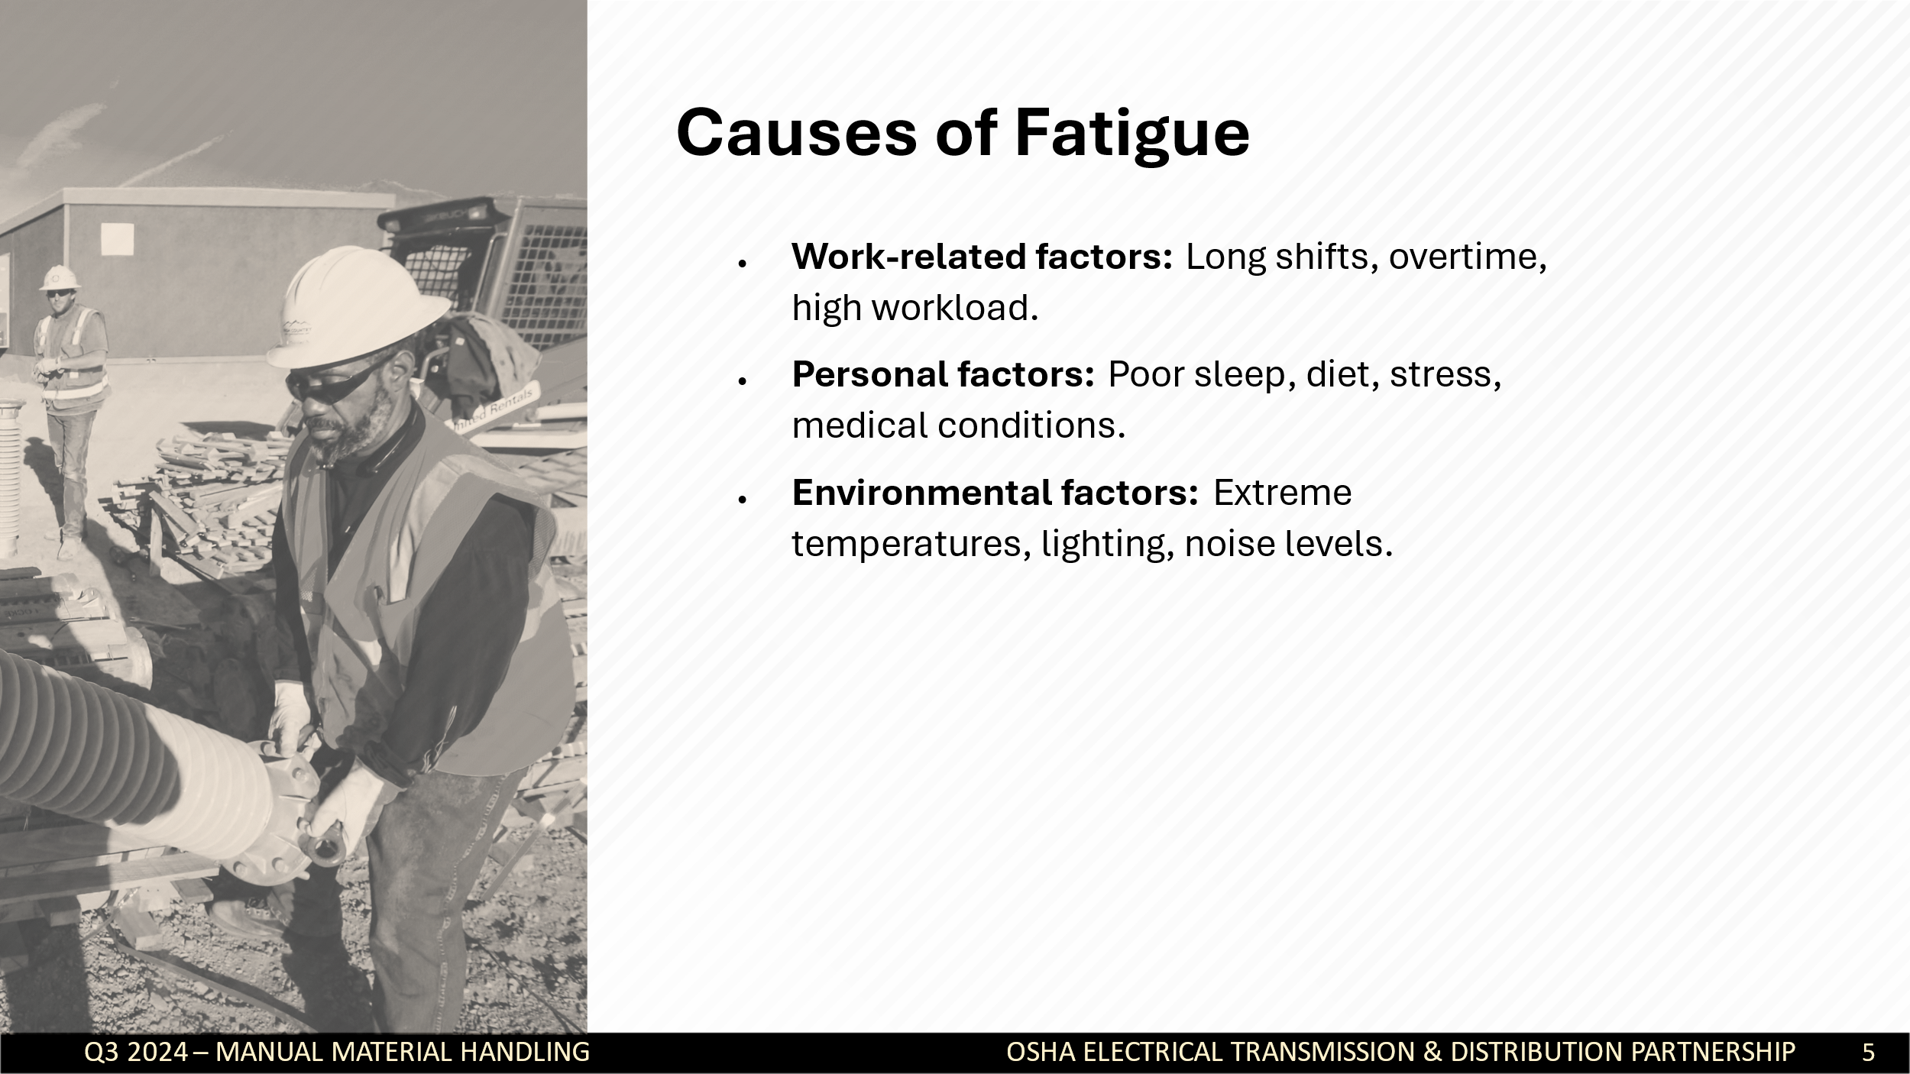
Work-Related Factors
Fatigue in the workplace is often caused by job demands. Common culprits include:
  - Long shifts and overtime:
    - Working extended hours reduces recovery time and increases exhaustion.
    - Example: "Studies show that working 12+ hour shifts regularly increases accident risk by 37%."
  - Repetitive or high-stress tasks:
    - Physically demanding jobs (e.g., linemen, construction workers) and mentally demanding jobs (e.g., dispatchers, engineers) can drain energy quickly.
  - Night shifts and irregular schedules:
    - Circadian rhythm disruption makes it harder to stay alert.
    - Employees working rotating shifts are at a higher risk of fatigue.
  - Workload pressure:
    - Too much work and too little recovery time creates chronic fatigue.
    - Example: "Rushing to meet deadlines without breaks can cause a productivity dip and increase errors."
Personal Factors
Fatigue isn’t just caused by work; our personal lives play a major role too.
  - Poor sleep habits:
    - Not getting 7-9 hours of quality sleep per night is a major fatigue contributor.
    - Ask: "How many of you consistently sleep at least 7 hours?" (Show of hands.)
  - Unhealthy diet & hydration:
    - Processed foods and high sugar intake cause energy crashes.
    - Not drinking enough water leads to dehydration, which increases fatigue.
  - Stress and mental health:
    - Anxiety, work-life balance struggles, and personal stressors drain energy.
  - Medical conditions & medications:
    - Sleep apnea, depression, and even certain medications can worsen fatigue.
Environmental Factors
- Workplace environment also impacts fatigue levels.
  - Temperature extremes:
    - Heat stress leads to dehydration, dizziness, and exhaustion.
    - Cold weather can cause slower reaction times and muscle fatigue.
  - Lighting conditions:
    - Dim lighting = eye strain & drowsiness.
    - Bright artificial light = disrupted sleep cycles if working late.
  - Noise levels:
    - Loud or constant noise can increase stress and exhaustion over time.
Discussion Activity (Optional)
- Pair and Share:
  - Question: "What do you think is the biggest fatigue factor in your job?"
  - Ask participants to discuss in pairs or small groups for 1-2 minutes.
  - Have a few volunteers share responses.

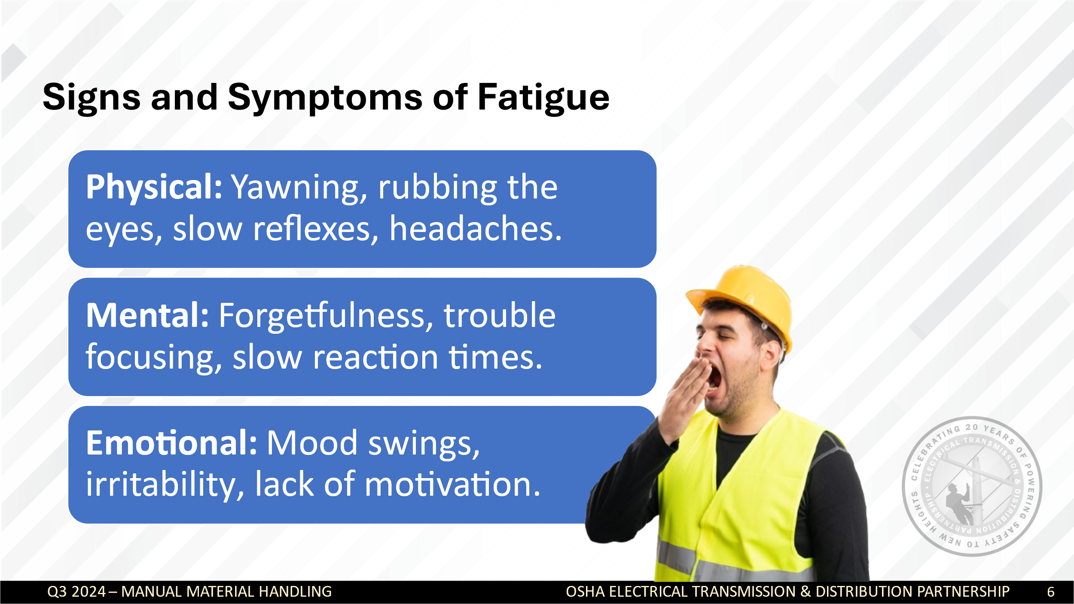
- Introduce the Topic
"Fatigue isn’t just about feeling sleepy. It impacts your body, mind, and emotions in ways that can compromise safety and performance. Recognizing the early warning signs of fatigue is key to preventing accidents and health issues."
- Ask: “What are some signs you notice when you’re feeling really tired at work?”
  - Take 1-2 participant responses.
  - Validate their answers and connect them to the listed symptoms on the slide.
2. Explain Physical Symptoms
"Physical fatigue is often the most noticeable, but people tend to ignore it. It’s more than just yawning—it affects coordination, reflexes, and even muscle control."
- Key points:
  - Yawning and eye fatigue are early warning signs.
  - Slow reflexes and clumsiness can lead to safety hazards (e.g., tripping, dropping tools, mishandling equipment).
  - Headaches or lightheadedness and muscle fatigue can signal that your body is overworked.
Interactive Question:
  - "Have you ever noticed your coordination getting worse when you’re tired? What happened?"
3. Discuss Mental Symptoms
"Fatigue doesn’t just slow the body—it also slows the brain. A fatigued mind is more likely to forget details, make mistakes, and struggle with decision-making."
- Key points:
  - Forgetfulness: You might misplace tools or forget important steps in a procedure.
  - Difficulty concentrating: Tasks take longer, and mistakes happen more often.
  - Slow reaction times: A delay in judgment can lead to near-misses or accidents.
  - Poor decision-making: Fatigue leads to risky choices or skipping safety steps to get things done faster.
- Scenario:
“Think about a time when you were exhausted but still had to make an important decision. Did it feel harder than usual? Did it lead to mistakes?”
  - Have one or two participants share examples.
4. Address Emotional Symptoms
"When we think about fatigue, we rarely think about its emotional impact. But exhaustion can make people short-tempered, anxious, or even disengaged from work."
- Key points:
  - Mood swings & irritability: Tired employees are more likely to snap at coworkers or struggle with teamwork.
  - Lack of motivation: Chronic fatigue can cause employees to lose interest in their job, leading to lower productivity.
  - Increased stress & anxiety: Long-term fatigue contributes to burnout and mental exhaustion.
- Discussion Prompt:
  - “Have you ever worked with someone who was clearly fatigued, and it affected their attitude or behavior? How did it impact the team?”

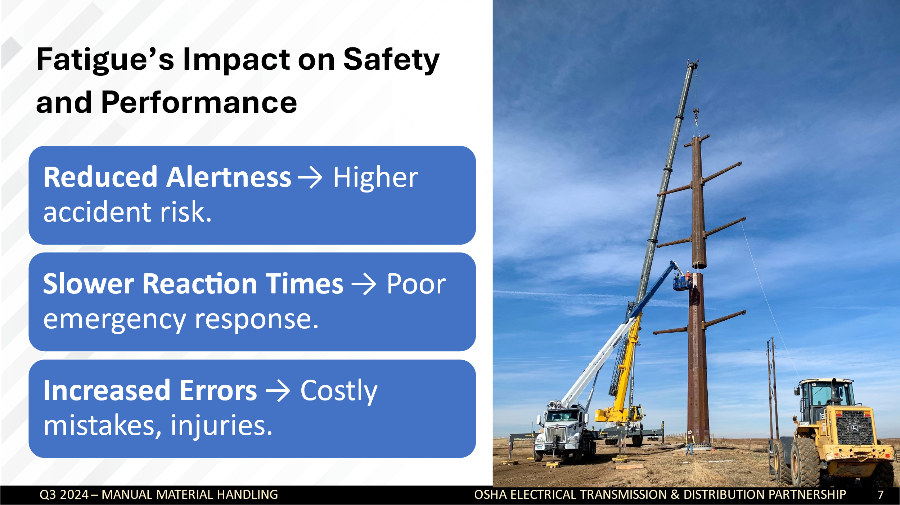

How Fatigue Affects Safety
"Reduced Alertness → Higher Accident Risk"
- Say: “Fatigue slows brain function, which reduces your ability to notice hazards. A tired worker may not see a trip hazard, fail to check equipment properly, or overlook a warning sign.”
- Example: Share an industry-specific fatigue-related accident (e.g., a lineman missing a safety step, a driver causing a crash, a technician making a critical error).
Slower Reaction Times → Poor Emergency Response
- Say: “Reaction time is significantly reduced when fatigued. If an emergency occurs—whether it’s a falling object, malfunctioning equipment, or a sudden hazard—fatigued workers take longer to respond.”
Increased Errors → Costly Mistakes, Injuries
- Say: “Fatigue leads to lapses in concentration and judgment, causing errors that could be costly—or even deadly. These errors aren’t just physical but can include forgetting procedures, miscalculating measurements, or failing to communicate crucial information.”
Stat: “According to safety studies, fatigue-related mistakes cost companies millions annually in lost productivity and accident-related expenses.”
Group Discussion: How Fatigue Affects You
- Ask the group:
  - “What are some tasks in your job that require full focus and reaction time?”
  - “Have you ever noticed a coworker struggling due to fatigue?”
- Encourage short responses (this keeps engagement high without sidetracking the session).

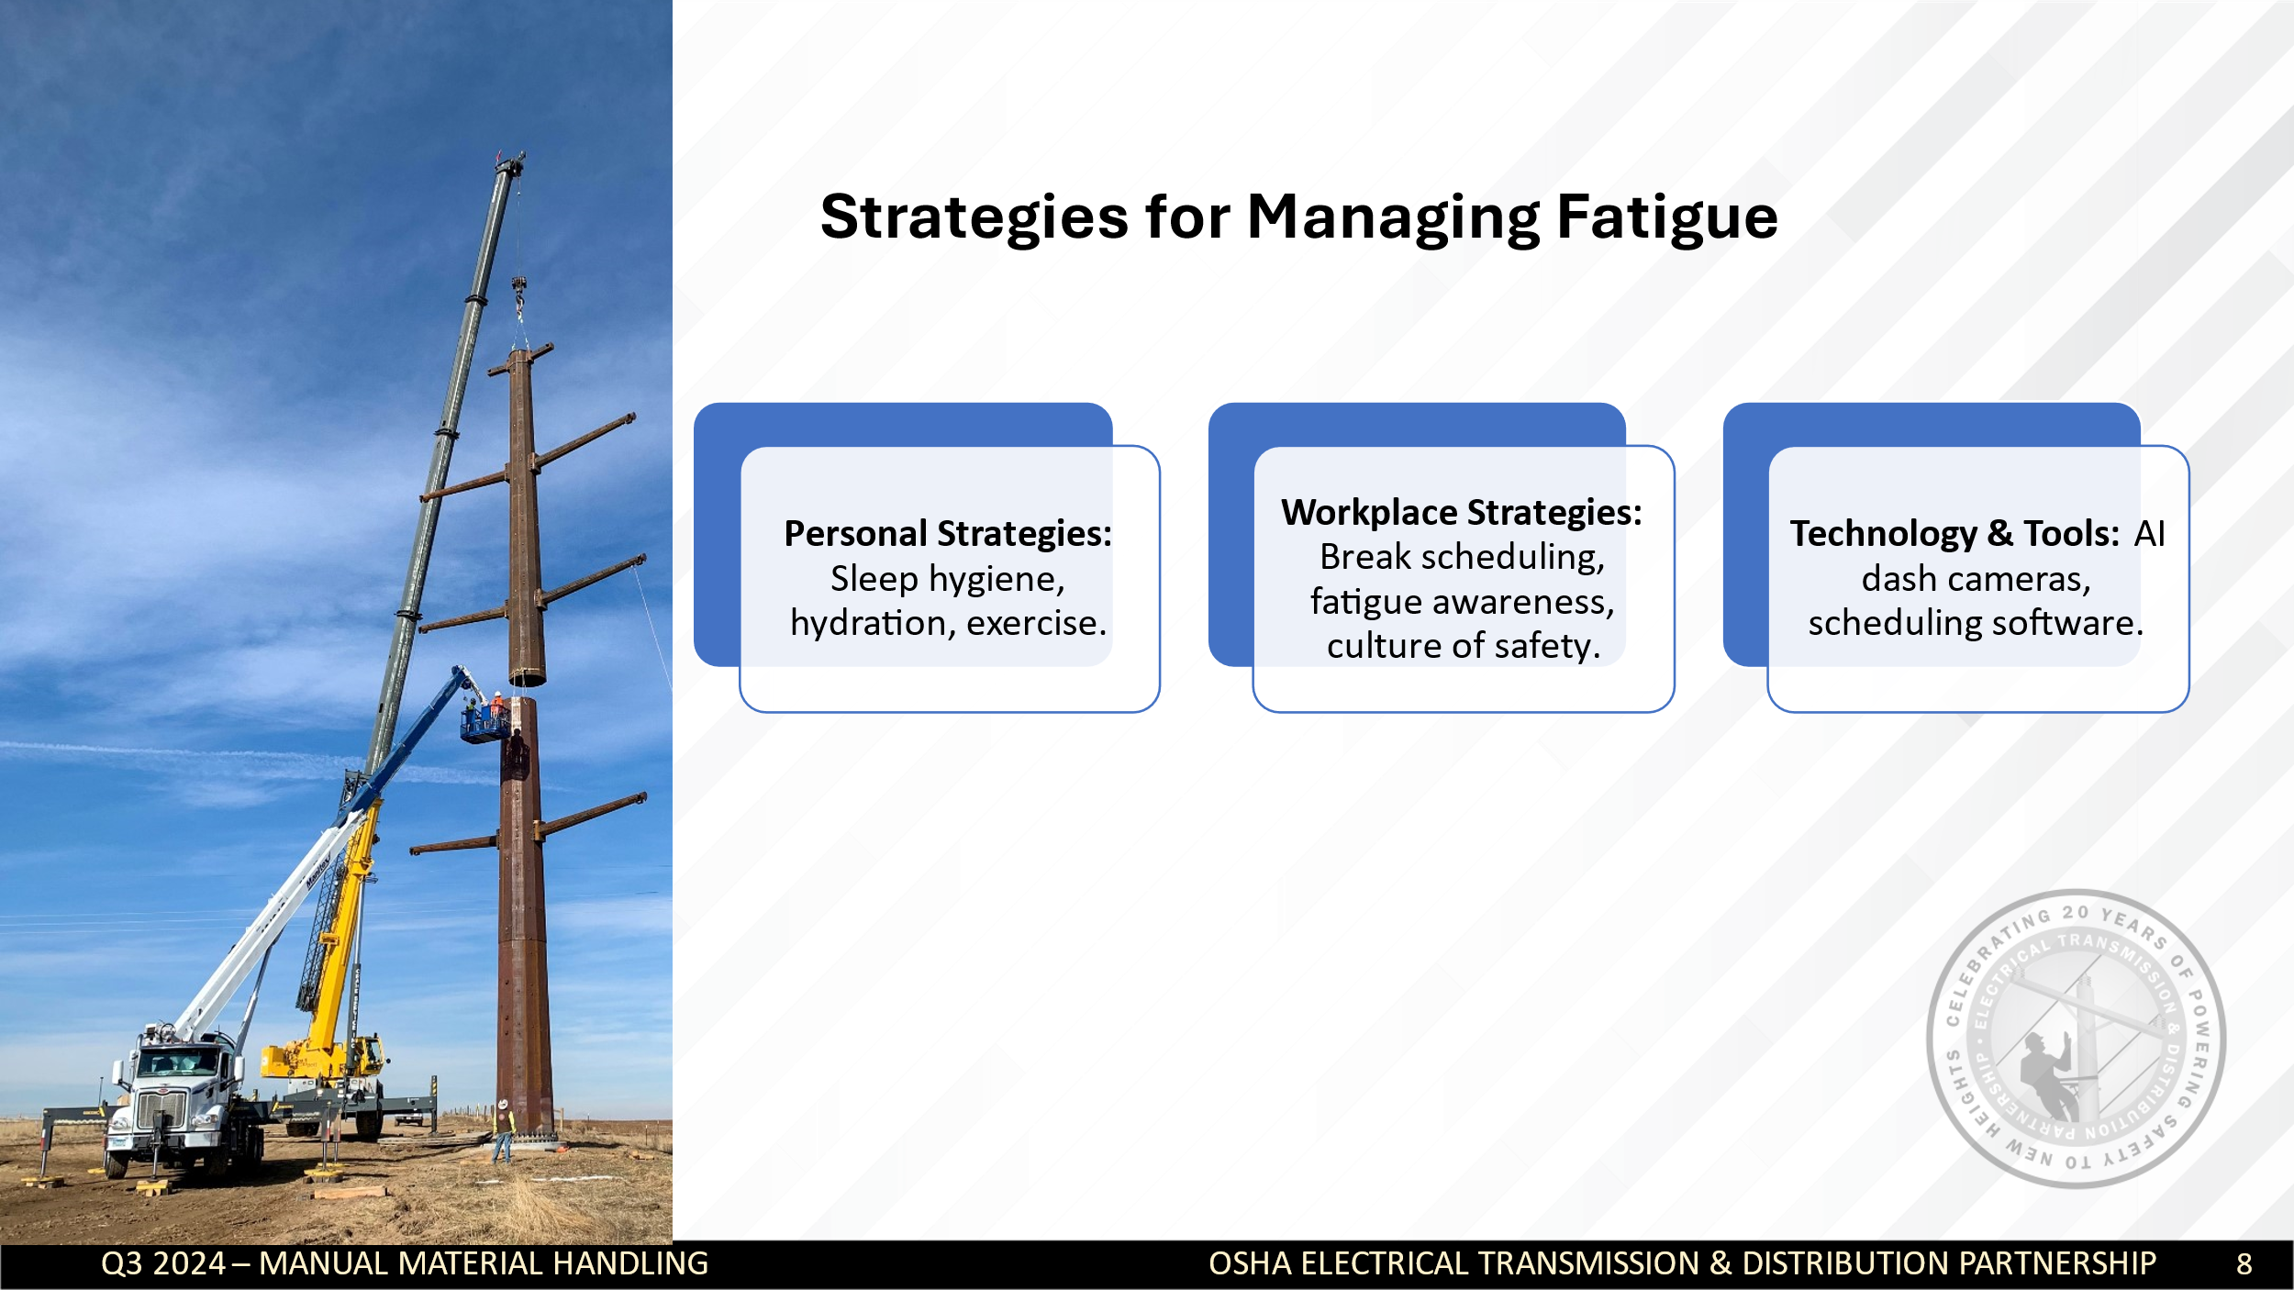
1. Personal Strategies (Self-Management) – “What Can You Do?”
"Fatigue starts with personal habits. We have more control over our energy levels than we might think."
✅ Sleep Hygiene:
- Stick to a consistent sleep schedule, even on days off.
- Aim for 7-9 hours of quality sleep per night.
- Create a dark, quiet, and cool sleep environment (avoid screens before bed).
✅ Nutrition & Hydration:
- Avoid heavy meals, caffeine, and alcohol for at least 4-6 hours before bedtime.
- Drink enough water throughout the day. Dehydration worsens fatigue.
- Eat high protein and low card snacks during th4 sleepiest part of the workday (3 - 5 AM and 3- 5 PM)
✅ Exercise & Movement:
- Regular physical activity boosts energy levels and helps with better sleep.
- Even small movement breaks throughout the workday can reduce fatigue.
✅ Stress Management:
- Chronic stress can lead to mental exhaustion.
- Breathing exercises, mindfulness, or short breaks can help manage stress.
🗣 Discussion Prompt:
- "Which of these personal strategies do you already use? Which ones do you struggle with?"
2. Workplace Strategies – “What Can Employers Do?”
"Fatigue isn’t just an individual issue—it’s also about how we structure our work environment."
✅ Shift Scheduling & Work Hours:
- Employers should avoid back-to-back shifts and ensure proper rest time between shifts.
- Rotating shifts can help prevent burnout (avoiding excessive night shifts).
✅ Encouraging Breaks & Rest Periods:
- Micro-breaks (5-10 minutes every hour) can improve focus.
- Longer breaks for meals and recovery should be enforced, not just encouraged.
✅ Fatigue Awareness Culture:
- Employees should feel comfortable reporting fatigue without fear of repercussions.
- Supervisors should watch for signs of fatigue in employees.
3. Technology & Tools – “How Can We Use Technology to Manage Fatigue?”
"New tools can help both individuals and organizations track and prevent fatigue."
✅ AI Dash Cameras & Driver Monitoring Systems:
- AI-powered dash cameras detect drowsy driving behaviors such as eyelid closure, head nodding, and loss of focus.
- These systems alert drivers in real-time and send reports to supervisors for coaching opportunities.
- AI dash cams help reduce accidents caused by fatigue, especially in transportation, construction, and energy industries.
✅ Wearable Devices:
- Some companies use wearable tech (smartwatches, fatigue detection sensors, eye-tracking software) to track fatigue signs.
- Some trucks and equipment now have AI-driven fatigue monitoring that alerts operators.
✅ Scheduling & Workload Management Apps:
- Apps can help optimize work shifts to reduce fatigue (e.g., fatigue risk management software).

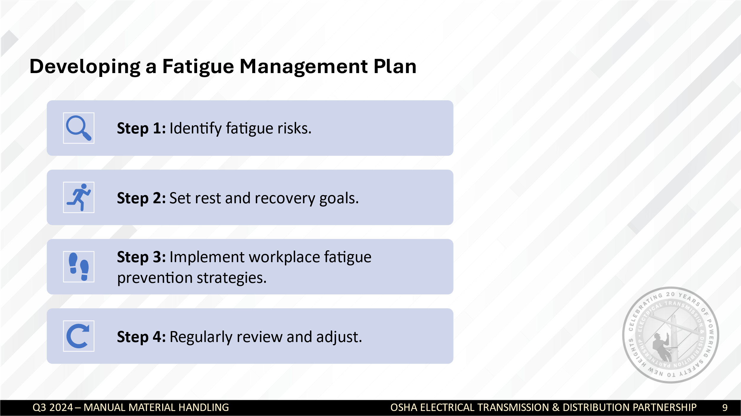

- Say:
“Now that we understand the risks and impacts of fatigue, let’s talk about a structured way to manage it. A fatigue management plan helps individuals and workplaces proactively reduce fatigue-related risks and promote a safer, more productive environment.”
- Ask:
“Has anyone ever had to change their habits to reduce fatigue at work? What worked for you?”
- Briefly acknowledge responses before introducing the structured steps.
2. Breakdown of the Fatigue Management Plan
Walk through the four steps, providing examples and engaging participants.
Step 1: Identify Fatigue Risks
- Explain:
“The first step is to recognize where fatigue is coming from. Is it from long hours? High workload? Lack of sleep? Environmental factors like noise or extreme temperatures?”
- Engage:
“Think about your job. What are the biggest fatigue risks in your role?”
  - (Take 2-3 responses and relate them to common workplace fatigue risks.)
- Example:
“A lineman working long shifts may struggle with physical fatigue, while a dispatcher might deal more with mental fatigue from high focus demands.”
Step 2: Set Rest and Recovery Goals
- Explain:
“Once you’ve identified fatigue risks, the next step is to create goals that promote recovery. These should be realistic and actionable.”
- Ask:
“What are some ways you personally recover from fatigue?”
  - (Encourage participants to share—e.g., better sleep habits, nutrition, exercise, short breaks.)
- Example:
“If poor sleep is an issue, a goal might be: ‘I will establish a consistent bedtime and reduce screen time 30 minutes before sleep.’”
- Pro Tip:
“Setting goals is easier when they’re specific. Instead of saying ‘get more sleep,’ say ‘aim for 7-8 hours per night by adjusting bedtime.’”
Step 3: Implement Workplace Fatigue Prevention Strategies
- Explain:
“Managing fatigue isn’t just about personal habits; workplaces must also play a role. Here are some strategies companies can use to reduce fatigue:”
  - Scheduling & Shift Adjustments: Avoid excessive overtime or consecutive long shifts.
  - Encouraging Breaks: Short, regular breaks prevent burnout.
  - Providing Education: Training employees to recognize fatigue risks.
  - Creating a Culture of Safety: Encouraging employees to speak up when fatigued.
- Engage:
“Does your company currently have any fatigue prevention policies? If so, how effective are they?”
  - (Encourage discussion. If none exist, ask what policies they think would help.)
Step 4: Regularly Review and Adjust the Plan
- Explain:
“A fatigue management plan isn’t a ‘set it and forget it’ process. Regular check-ins help ensure it’s working.”
  - Encourage employees to reflect on what’s working and adjust their strategies accordingly.
  - Supervisors should assess schedules and workloads periodically.
- Engage:
“What’s one thing you would personally change in your routine to reduce fatigue?”
  - (Allow 2-3 participants to share their responses.)

